Call for AY2023/24 Semester 1 and Full Academic Year Nominations (University-wide)
Jamie Tai <grojt@nus.edu.sg>
Dear Partners

Greetings from the National University of Singapore! We hope this email finds you well.

We are now accepting incoming exchange nominations for AY2023/24 Semester 1, August 2023 intake. Below is an update on our application processes and key information related to Exchange@NUS. Please feel free to share this information with your students who are coming to NUS for exchange this August.
If you have questions on the specific number of students you are able to send to NUS, please feel free to contact us.
Timelines & Updates
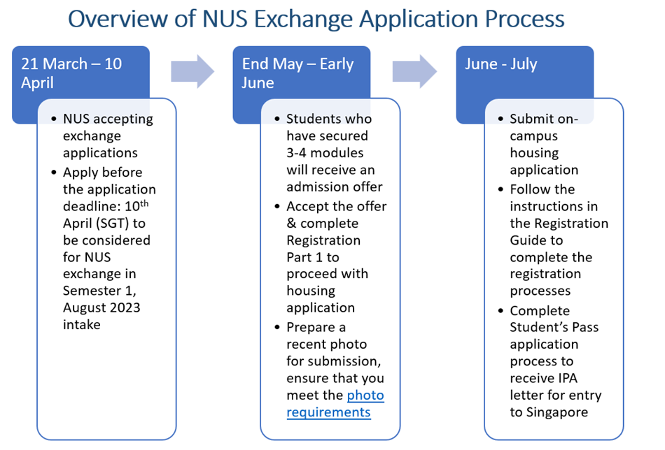
Nomination due:  20 March 2023  Please provide your students’ details using attached nomination sheet and send it to:  Jamie grojt@nus.edu.sg  Note:  • Please include your students’ university email address in your nomination and inform them to apply using the same email so that we can retrieve their application record from our online application portal and process their exchange application promptly. | Exchange application period:  21 March – 10 April 2023  Please inform your nominated students to submit an exchange application from 21st March to 10th April at:  https://myapplications.nus.edu.sg/  Note:  • Students are to register a new user account using their university email address (instead of their personal email)  • Select "University-level" for their specialisation/level of study in their application  • Students need to prepare 8 module choices for submission with their application  • Students who wish to be considered for on-campus housing have to indicate their interest in their application  • Refer to this link for more info. | Modules Selection  Refer to the NG Module List for the list of modules open to exchange students  (NUS Semester 1, 2023 modules will be updated closer to the start of Semester 1 exchange application)  Note:  • Students are to ensure that they meet the pre-requisites for the modules they apply for.  • Undergraduate students should select Level 1000 – 3000 modules. Please note that Level 4000 honours modules have very limited quota, so it is highly competitive to enrol into these modules. We strongly recommend exchange students to consider the Level 1000 – 3000 modules. Undergraduate students will not be considered for Level 5000 – 6000 graduate modules.  • Business and Law modules are limited and only offered to selected exchange students nominated through our Business and Law-specific agreements. Students nominated through the general University-wide or other faulty agreements will not be considered for Business and Law modules.  • Module enrolment is subject to availability and demand, students should have more flexibility in their module selections as there’s no guaranteed enrolment into any modules. We recommend that students prepare some back-up modules in the event of oversubscription or timetable clashes.  • Refer to this link for more info.
Immigration & Insurance  Travellers who fulfil the public health requirements listed here can enter Singapore without testing and quarantine.  Exchange students need to fulfil the vaccination requirements for holding a Student’s Pass. Refer to the question: “What combinations of vaccine doses do I need to fulfil the vaccination requirements for Long Term Pass Holders?” at the Singapore’s Ministry of Health website.  Exchange students are covered under the NUS Medical Insurance Scheme. For more info regarding COVID-related coverage, click here.  Students are strongly encouraged to purchase supplemental travel insurance to ensure they are adequately covered during their time abroad. | Student’s Pass  NUS Registrar’s Office will send the Student’s Pass application instructions to students who have accepted the NUS admission offer.  Note:  • Students need to login to Singapore Immigration ICA’s application portal to complete their Student’s Pass application  - Prepare the documents required in advance  - Monitor the application status regularly as you will be required to upload documents and make payments at different junctures of the application process on the portal within the stipulated deadlines by ICA. Failure to do so will result in your Student’s Pass application being withdrawn  - Once the application is approved, you will be issued an IPA letter for entry to Singapore. For students from a visa-required country, the IPA letter also serves as a single-entry visa to enter Singapore  - Complete the Student's Pass formalities after your arrival to Singapore. Book early to secure an Offsite Enrolment Exercise (OSE) in NUS appointment slot. | Accommodation  On-campus accommodation is limited and not guaranteed. Exchange students should seek off-campus accommodation options early as there is increasing demand from international students in Singapore.  Note:  • Useful resources for off-campus accommodation*:  - Off-campus accommodation  - Students’ testimonials with off-campus housing  - List of Private Student Hostels  - Other resources shared by inbound students*:  - Flat and Flatmates in Singapore (Facebook group)  - West Coast Village Residences  - https://www.airbnb.com.sg/  - https://www.metroresidences.com/  - https://www.universityliving.com/singapore/city/singapore  - https://www.nestpick.com/student-accommodation/singapore/  - https://cove.sg/student-accommodation  - https://www.novenahall.com.sg/  *Please note that these external sites and providers are not affiliated with NUS and the list is meant to be a helpful resource for students as they plan their accommodation for their exchange.
Useful Resources
NUS Exchange Information  Online resources:  - NUS Info Sheet  - NUS Global Website | See you in NUS Webinar  We’ll be conducting pre-arrival webinars for inbound students (tentatively in June 2023).  Exchange students will be invited to attend the webinars. | Latest COVID-19 Updates  NUS’ COVID-19 updates:  - NUS Resources  - Safe Management Measures  National sources of information:  - Singapore’s Ministry of Health  - Immigration & Checkpoints Authority
Thank you for your continued support for the NUS Student Exchange Programme.

We look forward to welcoming your students to NUS in August 2023.

Best regards
Jamie

Jamie TAI (Ms) :: Senior Manager :: NUS Global :: National University of Singapore :: Unit 03-03, Shaw Foundation Alumni House, 11 Kent Ridge Drive, Singapore 119244 :: +65 6516 8818 :: grojt@nus.edu.sg :: nus.edu.sg/gro :: facebook.com/nusglobal :: instagram.com/nusglobal :: Company Registration No: 200604346E

Important: This email is confidential and may be privileged. If you are not the intended recipient, please delete it and notify us immediately; you should not copy or use it for any purpose, nor disclose its contents to any other person. Thank you.

